The Coddenham Centre is working hard to reduce its carbon emissions.

We now provide toilet rolls by

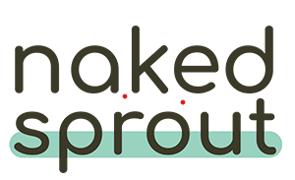

The UK’s most sustainable toilet roll 50% fewer carbon emissions than eco alternatives.
No bleach
No harsh chemicals
No plastics

