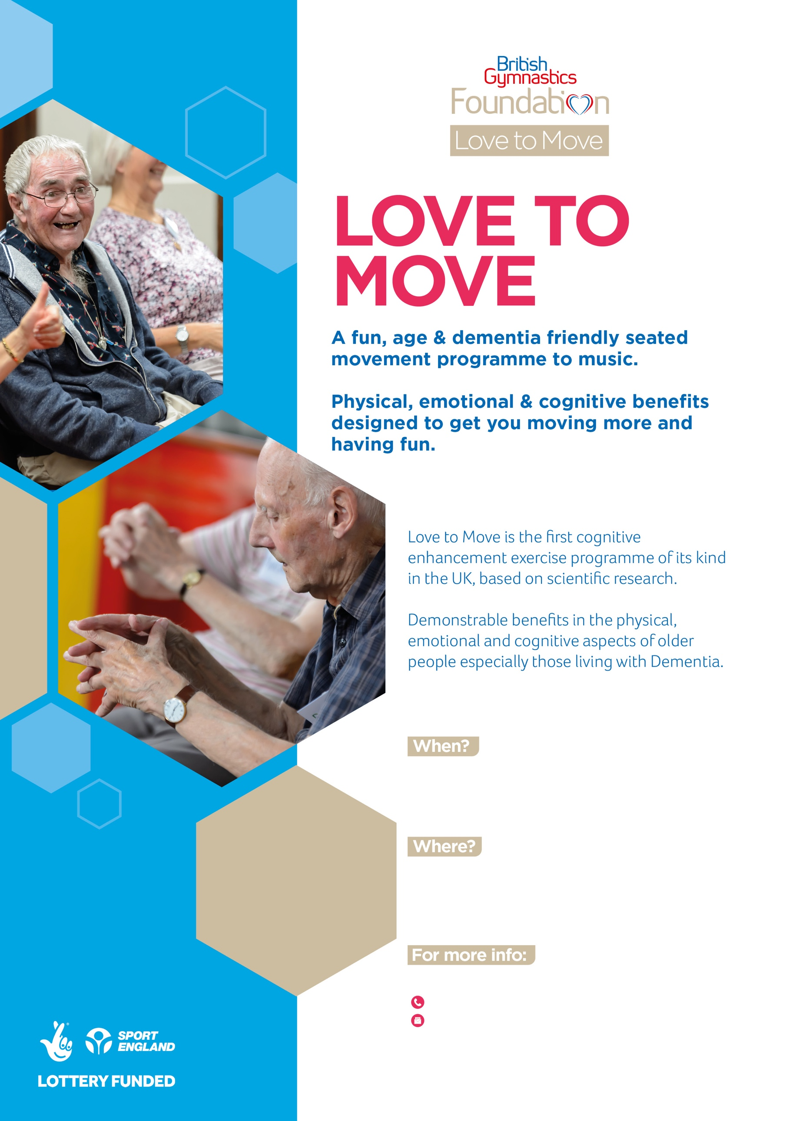
07941 497927
Susannah.taylor@britishgymnasticsfoundation.org

Sue Taylor
The Coddenham Centre
Mary Day Cl, Coddenham,
Ipswich IP6 9SR
No need
to book!
Free entry
Refreshments provided
Every Thursday
2-4pm

